Royal Road Home & School Association
Christmas Gift Basket Raffle

Win 1 of 6 fabulous Christmas gift baskets!

************************************************************************

In case you can’t make it to the Christmas Concert on December 12th, tickets are being sent home. They can be photocopied if you need more, and they can also be found on the school website in the Documents section (royalroad.nbed.nb.ca). Sell to your family and friends!!

Tickets are $2 each, 3 for $5, or 10 for $10. Enter your name and phone number, and indicate on the back of each ticket to which basket you would like to have that ticket added.

Basket themes are:
- Toys/Games
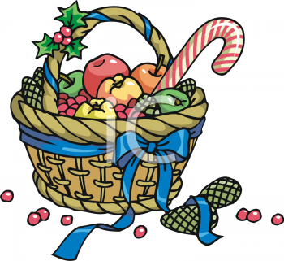
- Gift Cards
- Family Fun Night
- Holiday Baking
- Pets
- Books

Pictures of the baskets will be available on the school website by Weds, Dec 4th.

Please return all tickets and money by Weds, Dec 11th. Money must accompany tickets to be added to the draw. Remember to indicate on the back of each ticket which basket(s) you are hoping to win. Draw will take place on Thurs, Dec 12th after the concert.

Good luck!! Thank you for your support. All proceeds will go towards purchasing equipment and materials for our children’s classrooms to enrich their learning experience.

Royal Road Home & School Association

